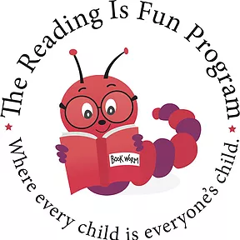
Reading Is Fun Scrabble-Rama
Saturday, June 1, 2024
8:30 am – 11:30 am
Schenectady High School Cafeteria

REGISTRATION FORM:
**Deadline to register is Wednesday, May 15, 2024**

Team Contact Name: _______________________________ Phone: ____________________
Address: _____________________________________________________________________
Email: _________________________________________________
Team Name: ____________________________________________
Team Players:
- _________________________________________________
- _________________________________________________
- _________________________________________________
- _________________________________________________

Registration Fee: $20.00 per player (2– 4 players per team ages 18 and up)
Make check* payable to: SCSDEF (Schenectady City School District Educational Foundation)
*In check memo write: RIF Scrabble
Send registration form and check to:
RIF, P.O. Box 9437, Schenectady, NY 12309
For questions about the event or registration, contact Nancy at 518-388-8410 or email russo5times@gmail.com.
- I am unable to attend the event, but please find my tax deductible donation to RIF in the amount of $_________.

